Universidad Tecnológica Nacional Facultad Regional Villa María Inglés 2

Trabajo Práctico N° 1

Read this example:

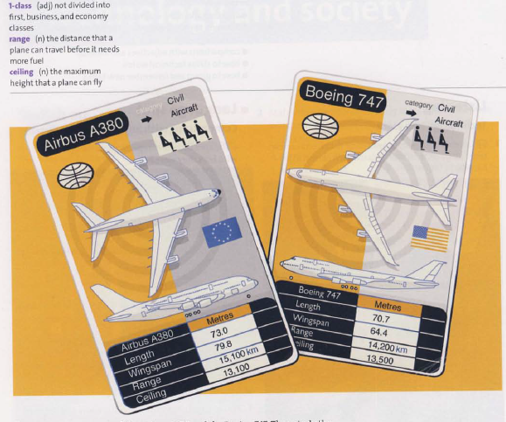

Read this paragraph comparing Airbus A380s and Boeing 747s.

Boeing 747s are smaller and lighter than Airbus A380s, so they can go faster. Boeings can also fly

higher. But Airbus A380s can carry larger numbers of people because they are longer and wider. They

have more powerful engines, and they can fly further than Boeings. So which are better? Boeings are

better when speed is important, but Airbuses have better capacity and range.

**Assignment: Write a paragraph comparing two items from the following list. Choose a pair of items.**

* A desktop computer or a laptop computer.
* Two cars.
* Two cell phones.
* Two landmarks or monuments.
* Two cities or countries.
* Two sports.
* Two kinds of food.